**Assignment-21.1:**

**Problem Statement :**

Write a mapreduce program to use CombineFileInputFormat. Pass a directory containing multiple small files. The program should be able to pick multiple files in a single mapper.

Creating directory named combine and putting three files into that directory. Later we will combine these file using combine file Input format.

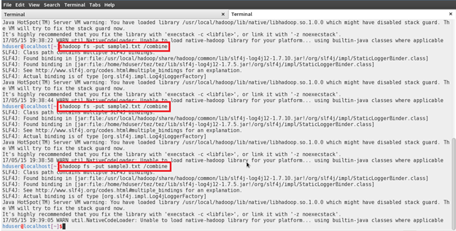

Files in the hdfs directory:

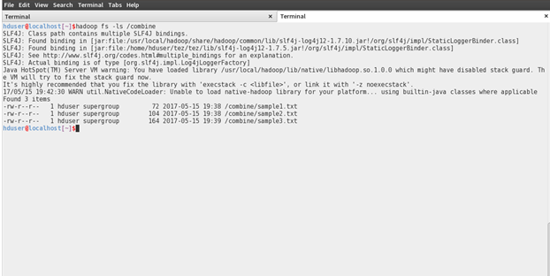

Screenshots of the MapReduce program:

Driver Class:

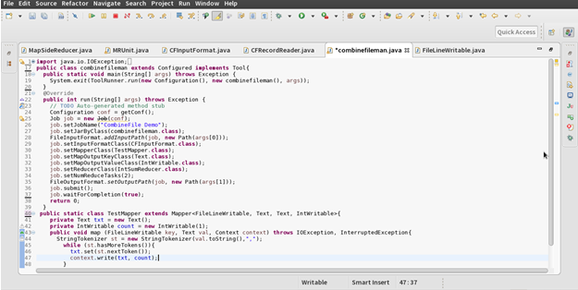

Combine File Input Format:

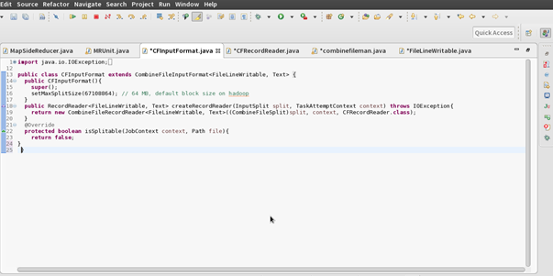

Combine File Record Reader:

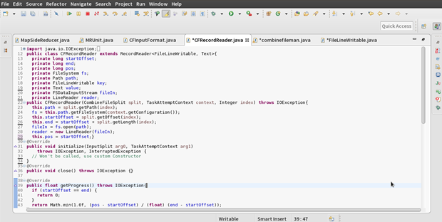

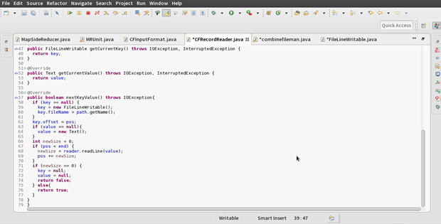

File Line Writable:

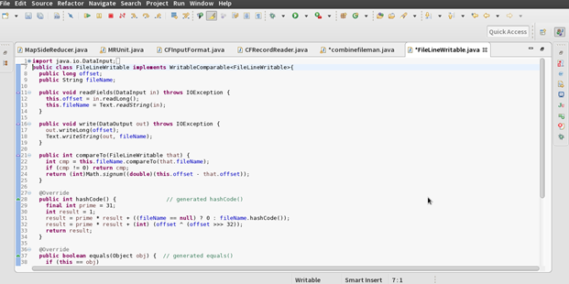

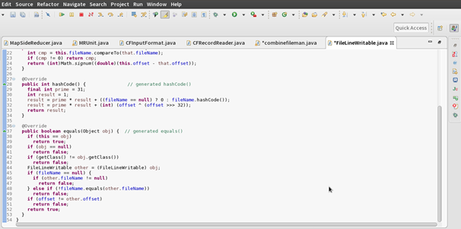

Running the jar file and storing the output in the directory named combine-op:

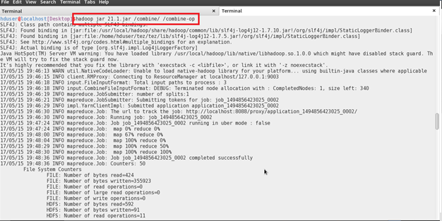

JobHistory Server was started and we can see that the program was able pick up the files in a single mapper:

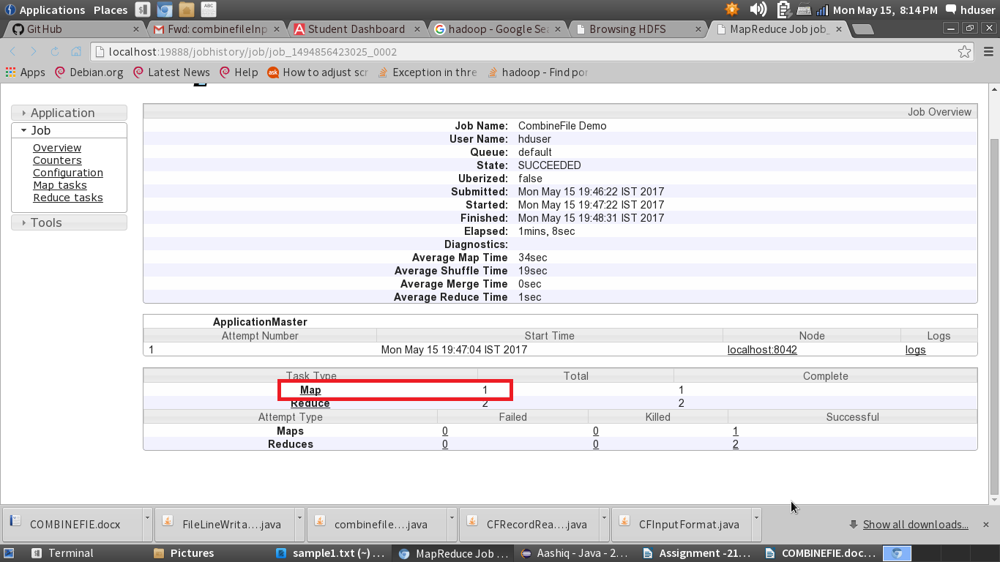

In the combine-op directory we can see that the output file is created

